**QUIZ 1**

|  |  |  |  |  |  |  |  |  |  |  |  |  |  |  |  |  |  |  |  |  |  |  |  |  |  |  |  |  |  |  |  |  |  |  |  |  |  |  |  |  |  |  |  |  |  |  |  |  |  |  |  |  |
| --- | --- | --- | --- | --- | --- | --- | --- | --- | --- | --- | --- | --- | --- | --- | --- | --- | --- | --- | --- | --- | --- | --- | --- | --- | --- | --- | --- | --- | --- | --- | --- | --- | --- | --- | --- | --- | --- | --- | --- | --- | --- | --- | --- | --- | --- | --- | --- | --- | --- | --- | --- | --- |
| **• Question 1**  10 out of 10 points   |  |  |  |  |  | | --- | --- | --- | --- | --- | |  |  | | | | |  | In the field of databases, there are several terms that mean the same thing.  Match the following terms with the closest synonym. |  |  |  | | |  |  |  |  |  |  | | --- | --- | --- | --- | --- | --- | | |  | | --- | | Question | | Record | | Field | | Junction | | Recordset | | |  |  |  |   **• Question 2**  10 out of 10 points   |  |  |  |  |  | | --- | --- | --- | --- | --- | |  |  | | | | |  | A "Primary Key" by default is always: (check all that apply) |  |  |  | | |  | | --- | |  | |  |  |  |   **• Question 3**  10 out of 10 points   |  |  |  |  |  |  | | --- | --- | --- | --- | --- | --- | |  |  | | | | | |  | A field that has the potential to be a unique identifier, but has not yet been chosen is called a: | |  |  |  | |  |  |  |  |  | |

**QUIZ 2**

* **Question 1**

5 out of 5 points

|  |  |  |  |  |
| --- | --- | --- | --- | --- |
|  |  | | | |
|  | Which of the following statements accurately choose ALL columns and ALL fields from a table in the database. |  |  |  |
| |  | | --- | |  | |  |  |  |

* **Question 2**

3 out of 5 points

|  |  |  |  |  |
| --- | --- | --- | --- | --- |
|  |  | | | |
|  | Choose all that apply, which parts of a table are REQUIRED in practice when creating a SELECT statement involving more than one table. |  |  |  |
| |  | | --- | |  | |  |  |  |

* **Question 3**

15 out of 15 points

|  |  |  |  |  |  |
| --- | --- | --- | --- | --- | --- |
|  |  | | | | |
|  | Write the SQL query that will show both the teamname and playername for all players in the league. | |  |  |  |
|  |  |  |  |  |

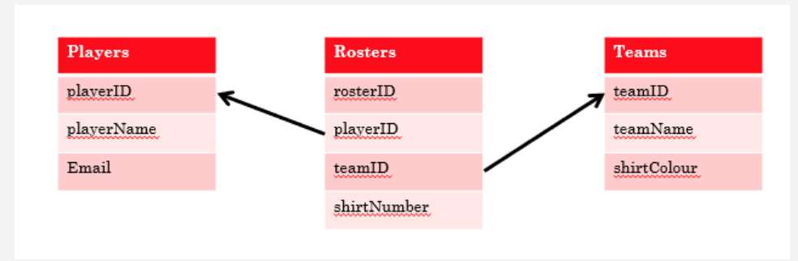

**QUIZ 6**

|  |  |  |  |  |  |  |  |  |  |  |  |  |  |  |  |  |  |  |  |  |  |  |  |  |  |  |  |  |  |  |  |  |  |  |  |  |  |  |  |  |  |  |  |  |  |  |  |  |  |  |  |  |  |  |  |  |  |  |  |  |  |  |  |  |  |  |  |  |  |  |  |  |  |  |  |  |  |  |  |  |  |  |  |  |  |  |  |  |  |  |  |  |  |  |
| --- | --- | --- | --- | --- | --- | --- | --- | --- | --- | --- | --- | --- | --- | --- | --- | --- | --- | --- | --- | --- | --- | --- | --- | --- | --- | --- | --- | --- | --- | --- | --- | --- | --- | --- | --- | --- | --- | --- | --- | --- | --- | --- | --- | --- | --- | --- | --- | --- | --- | --- | --- | --- | --- | --- | --- | --- | --- | --- | --- | --- | --- | --- | --- | --- | --- | --- | --- | --- | --- | --- | --- | --- | --- | --- | --- | --- | --- | --- | --- | --- | --- | --- | --- | --- | --- | --- | --- | --- | --- | --- | --- | --- | --- | --- |
| **• Question 1**  3 out of 3 points   |  |  |  |  |  | | --- | --- | --- | --- | --- | |  |  | | | | |  | Which of the following BEST describe the **model** part of data modelling! |  |  |  | | |  | | --- | |  | |  |  |  |   **• Question 2**  9 out of 9 points   |  |  |  |  |  | | --- | --- | --- | --- | --- | |  |  | | | | |  | Place the following data modeling steps in the correct order. |  |  |  | | |  |  |  |  |  |  |  |  |  |  |  | | --- | --- | --- | --- | --- | --- | --- | --- | --- | --- | --- | | |  | | --- | | Question | | 1 | | 2 | | 3 | | 4 | | 5 | | 6 | | 7 | | 8 | | 9 | | |  |  |  |   **• Question 3**  2 out of 2 points   |  |  |  |  |  | | --- | --- | --- | --- | --- | |  |  | | | | |  | According to your professor, which of the following steps are the least important part of the data modeling process |  |  |  | | |  | | --- | |  | |  |  |  |   **• Question 4**  7 out of 7 points   |  |  |  |  |  | | --- | --- | --- | --- | --- | |  |  | | | | |  | Match the synonyms.... |  |  |  | | |  |  |  |  |  |  |  |  |  | | --- | --- | --- | --- | --- | --- | --- | --- | --- | | |  | | --- | | Question | | Row | | Column | | row,column | | table | | optionality | | junction | | entity | | |  |  |  |   **• Question 5**  0 out of 3 points   |  |  |  |  |  |  | | --- | --- | --- | --- | --- | --- | |  |  | | | | | |  | Given the following business rules, determine which ERD best reflects the database design required:   * + A **Course**can be taught by only one **Professor**   + A **Professor** can teach multiple **courses**, but must teach **at least 1 course** | |  |  |  | |  |  |  |  | |

